Q:2

Full Factorial Design
Factors: 2 Base Design: 2, 4
Runs: 12 Replicates: 3
Blocks: 1 Center pts (total): 0

Factorial Regression: Yield versus Temperature, Pressure
H₀₁: All row treatment (levels of temperature) is equal. (H₀₁: α_{i} = 0; i= 1,2)
H₀₂: All column treatment (level of pressure) is equal. (H₀₂: β_{j} = 0; j= 1,2)
H₁₂: All row and column treatment interaction effects are equal.
(H₁₂: γ_{ij} = 0; i=j = 1,2)

OR
H₀₁: All row treatment (levels of temperature) is not significant.
(H₀₁: α_{i} = 0; i= 1,2)
H₀₂: All column treatment (level of pressure) is not significant.
(H₀₂: β_{j} = 0; j= 1,2)
H₁₂: All row and column treatment interaction effects are not significant.
(H₁₂: γ_{ij} = 0; i=j = 1,2)

Analysis of Variance

Source DF Adj SS Adj MS F-Value P-Value
Model 3 0.449167 0.149722 6.20 0.018
Linear 2 0.441667 0.220833 9.14 0.009
Temperature 1 0.140833 0.140833 5.83 0.042
Pressure 1 0.300833 0.300833 12.45 0.008
2-Way Interactions 1 0.007500 0.007500 0.31 0.593
Temperature*Pressure 1 0.007500 0.007500 0.31 0.593
Error 8 0.193333 0.024167
Total 11 0.642500

Conclusion:
From the ANOVA table, the p-value for Temperature and pressure is smaller than the α-value (α= 0.05), the hypothesis is rejected. that is, the temperature and pressure levels are significant. Since p-value for interaction for temperature and pressure is larger than the α-value (α= 0.05), it is concluded that there is no interaction effect between temperature and pressure.

Model Summary

S R-sq R-sq(adj) R-sq(pred)
0.155456 69.91% 58.63% 32.30%

Coded Coefficients

Term Effect Coef SE Coef T-Value P-Value VIF
Constant 90.5250 0.0449 2017.21 0.000
Temperature 0.2167 0.1083 0.0449 2.41 0.042 1.00
Pressure 0.3167 0.1583 0.0449 3.53 0.008 1.00
Temperature*Pressure -0.0500 -0.0250 0.0449 -0.56 0.593 1.00

Regression Equation in Uncoded Units

Yield = 89.317 + 0.00367 Temperature + 0.00517 Pressure - 0.000010 Temperature*Pressure

A regression model based on the coded observation is as follows:
Y = 90.525 + 0.1083 x₁ + 0.3167 x₂
The equivalent uncoded model based on the original data can be obtained as follows:
Y = 89.317 + 0.00367 x₁ + 0.00517 x₂

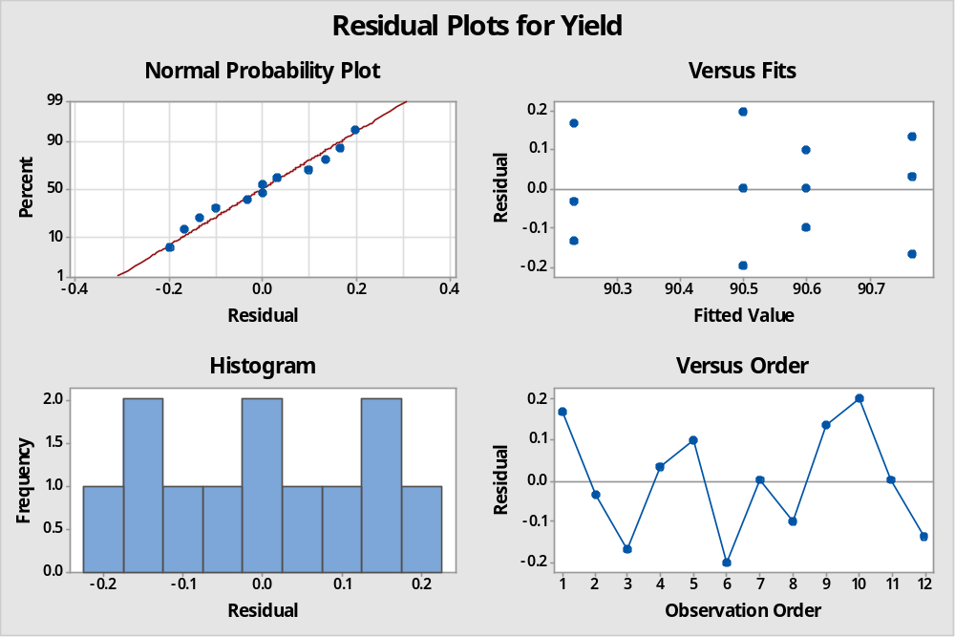
The residual analysis does not show any kind of unusual observations. The residuals are normal, and the run orders are also random.

Q:3
Full Factorial Design

Factors: 3 Base Design: 3, 8
Runs: 16 Replicates: 2
Blocks: 1 Center pts (total): 0

Factorial Regression: Firing Time versus Factor A, Factor B, Factor C
H₀₁: levels of Factor A is not significant.
(H₀₁: α_{i} = 0; i= 1,2)
H₀₂: level of Factor B is not significant.
(H₀₂: β_{j} = 0; j= 1,2)
H₀₃: level of Factor C is not significant.
(H₀₃: µ_{k} = 0; k= 1,2)
H₁₂₃: All row and column treatment interaction effects are not significant.
(H₁₂: γ_{ijk} = 0; i=j=k= 1,2)

Analysis of Variance

Source DF Adj SS Adj MS F-Value P-Value
Model 7 1236.94 176.705 36.72 0.000
Linear 3 1146.69 382.229 79.42 0.000
Factor A 1 588.06 588.063 122.19 0.000
Factor B 1 473.06 473.063 98.30 0.000
Factor C 1 85.56 85.562 17.78 0.003
2-Way Interactions 3 90.19 30.062 6.25 0.017
Factor A*Factor B 1 76.56 76.562 15.91 0.004
Factor A*Factor C 1 3.06 3.063 0.64 0.448
Factor B*Factor C 1 10.56 10.563 2.19 0.177
3-Way Interactions 1 0.06 0.063 0.01 0.912
Factor A*Factor B*Factor C 1 0.06 0.063 0.01 0.912
Error 8 38.50 4.813
Total 15 1275.44

Model Summary

S R-sq R-sq(adj) R-sq(pred)
2.19374 96.98% 94.34% 87.93%

Coded Coefficients

Term Effect Coef SE Coef T-Value P-Value VIF
Constant 26.688 0.548 48.66 0.000
Factor A -12.125 -6.062 0.548 -11.05 0.000 1.00
Factor B -10.875 -5.438 0.548 -9.91 0.000 1.00
Factor C -4.625 -2.313 0.548 -4.22 0.003 1.00
Factor A*Factor B -4.375 -2.188 0.548 -3.99 0.004 1.00
Factor A*Factor C 0.875 0.438 0.548 0.80 0.448 1.00
Factor B*Factor C 1.625 0.813 0.548 1.48 0.177 1.00
Factor A*Factor B*Factor C 0.125 0.063 0.548 0.11 0.912 1.00

Regression Equation in Uncoded Units

Firing Time = 79.4 + 4.4 Factor A - 3.475 Factor B - 0.001594 Factor C
- 0.975 Factor A*Factor B + 0.000031 Factor A*Factor C
+ 0.000081 Factor B*Factor C + 0.000006 Factor A*Factor B*Factor C

A regression model based on the coded observation is as follows:
Y = 26.688 -6.062 x₁ – 5.428 x₂ – 2.313 x₃ -2.188 x₁₂
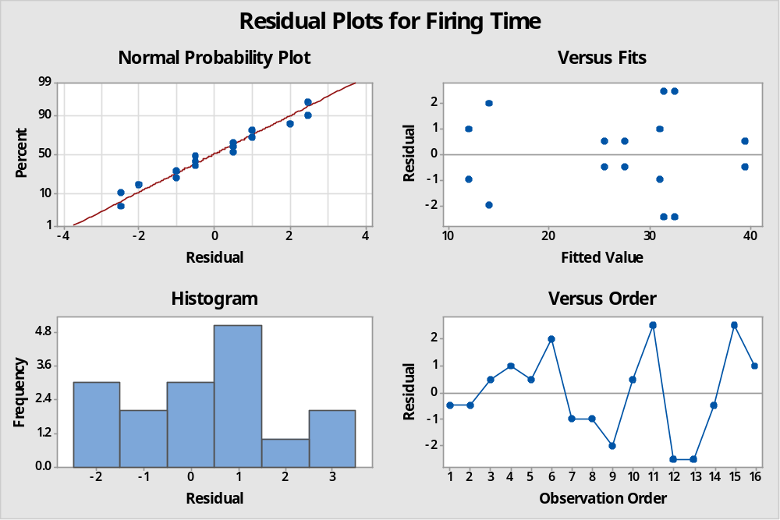
The residual analysis does not show any kind of unusual observations. The residuals are normal, and the run orders are also random.

